**SCREEN SHOTS USING POSTMAN**

**To list all the employees**

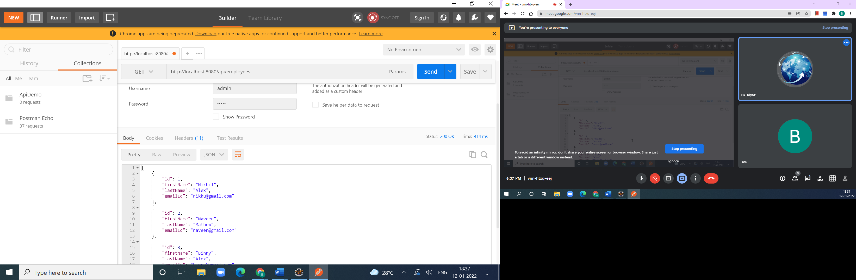

**Adding the Employee**

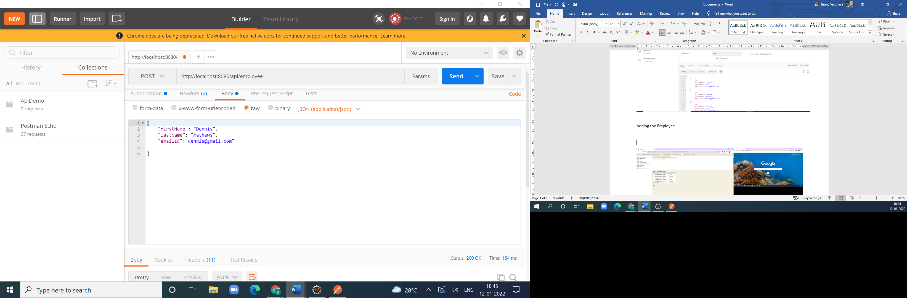

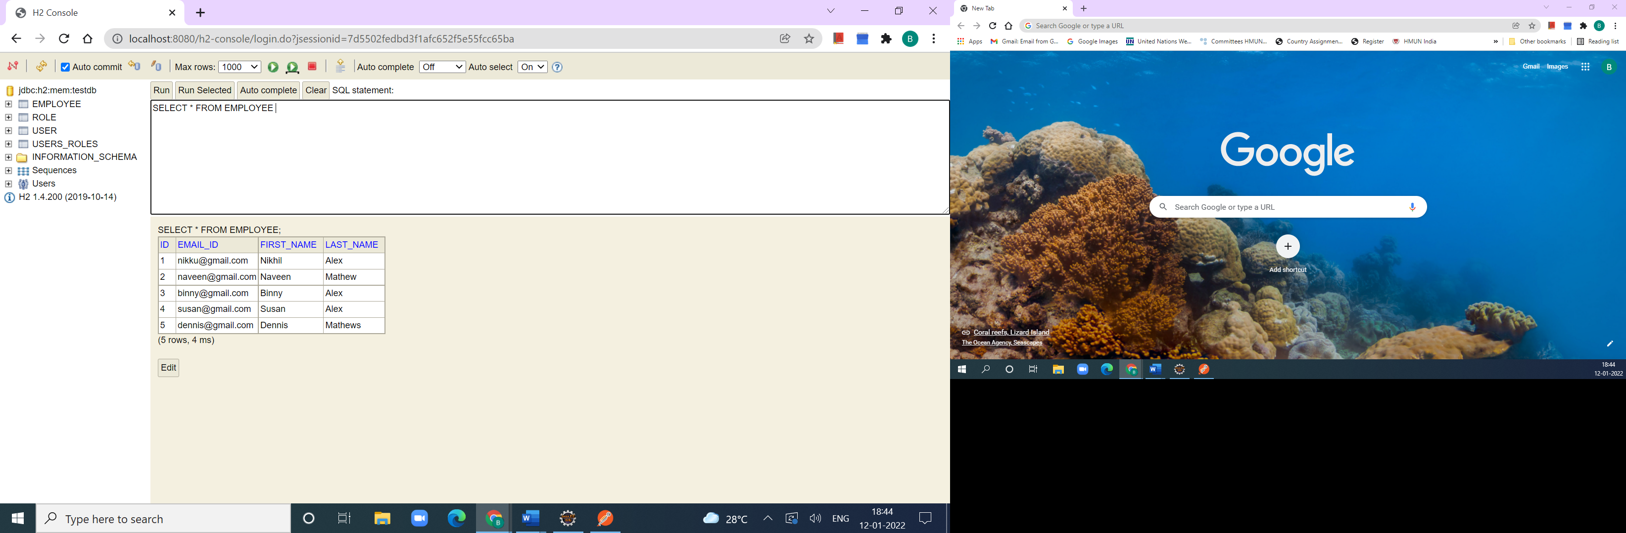

**UPDATE THE E MPLOYEE**

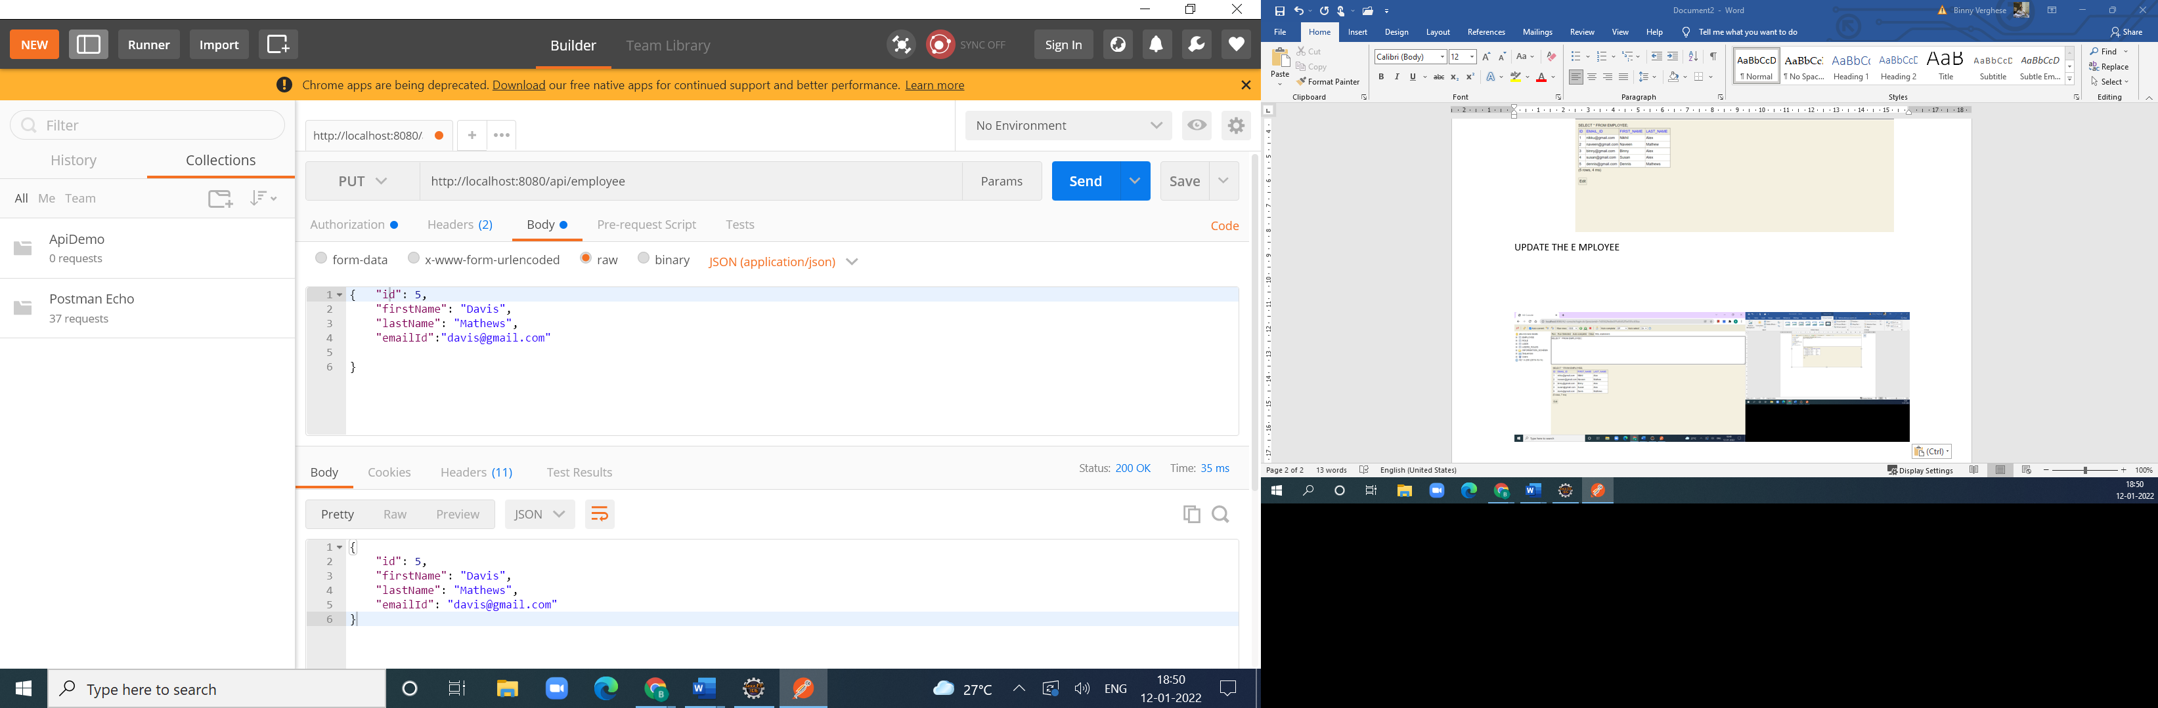

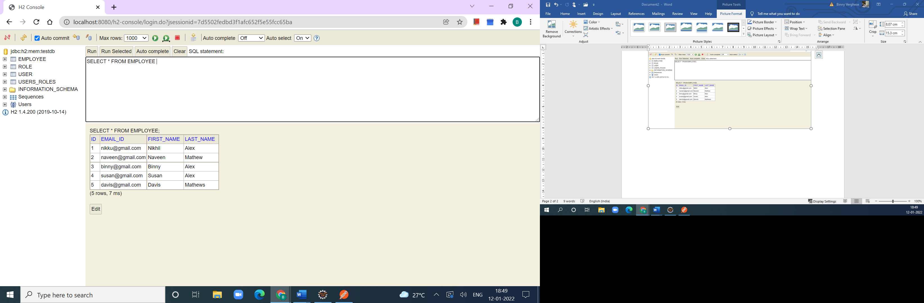

**DELETE THE EMPLOYEE**

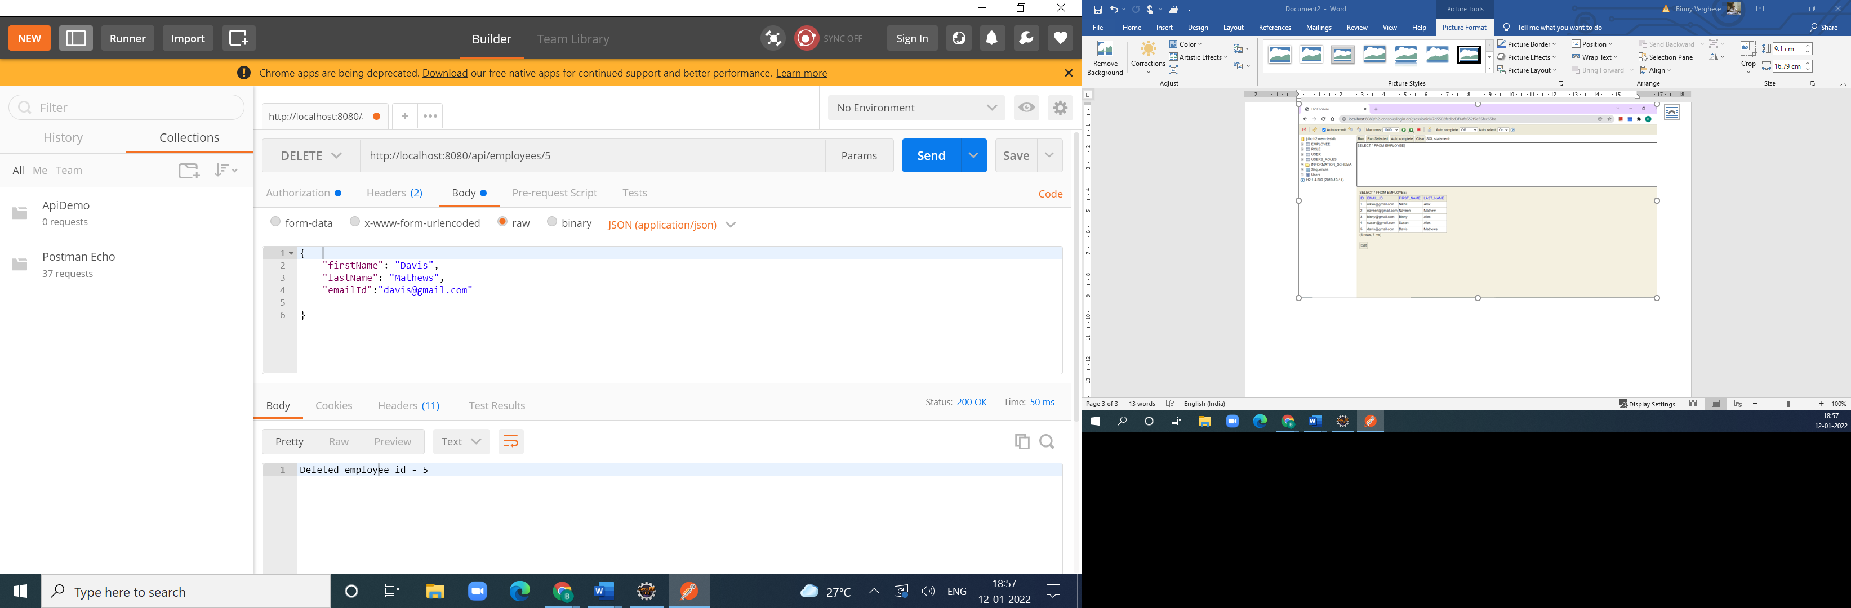

**SEARCH BY FIRST NAME**

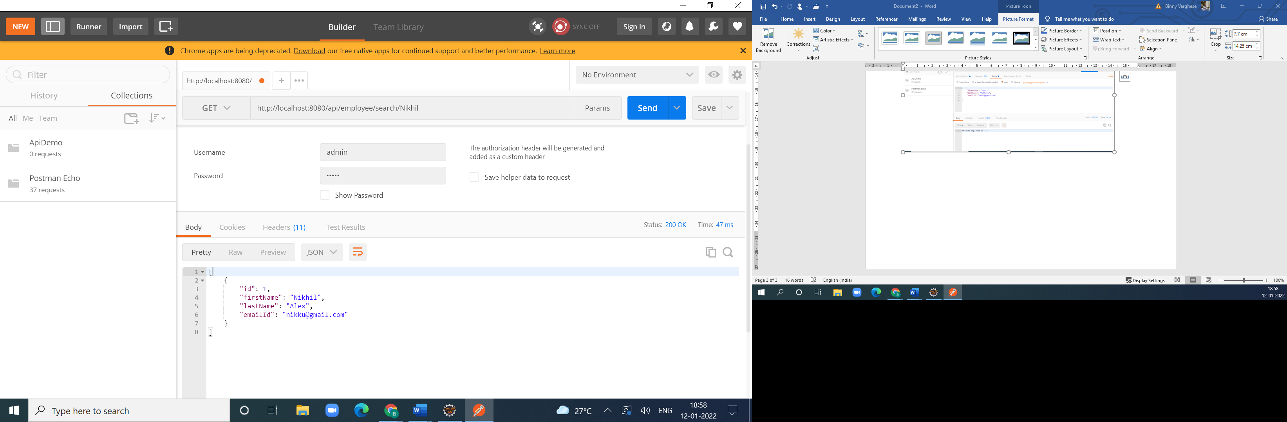

**SORTING IN ASCENDING ORDER ACCORDING FIRST NAME**

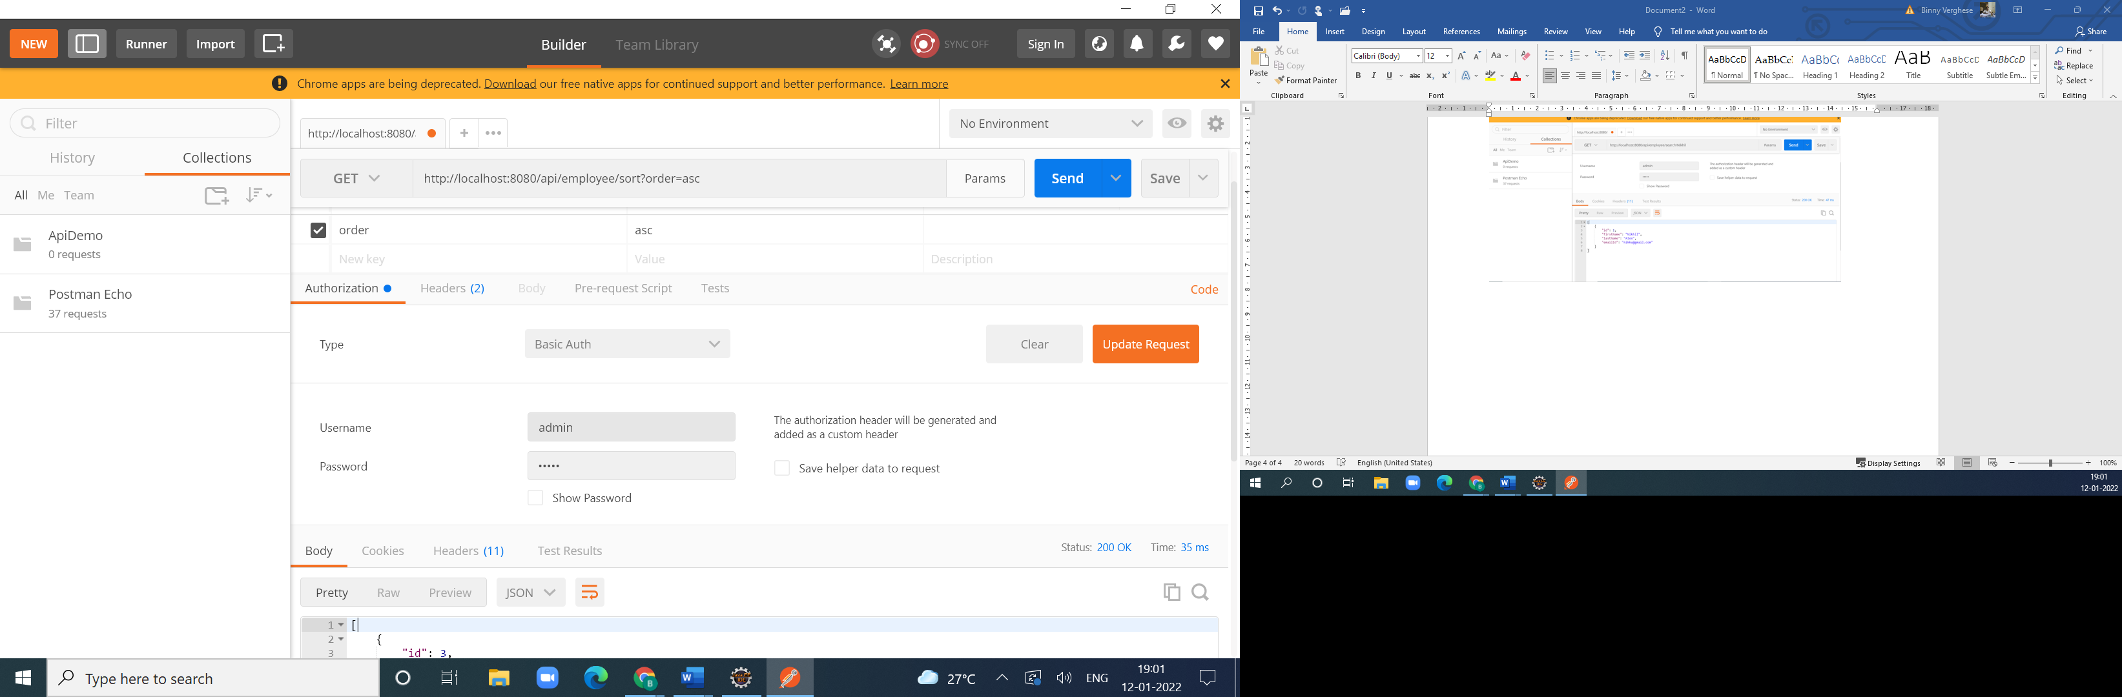

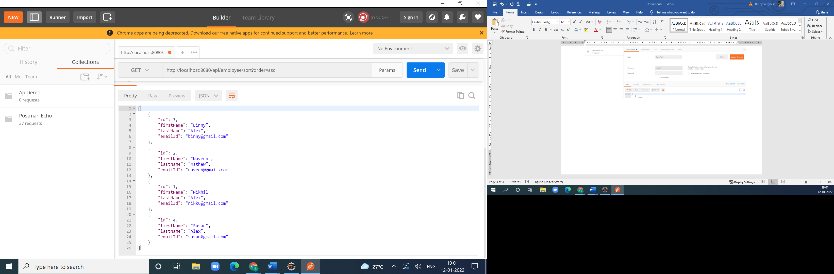

**SORTING IN DESCENDING ORDER**

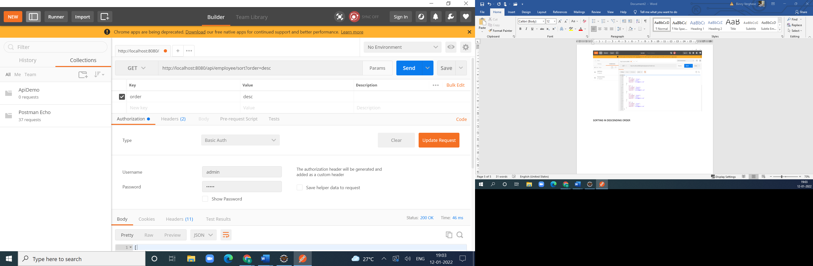

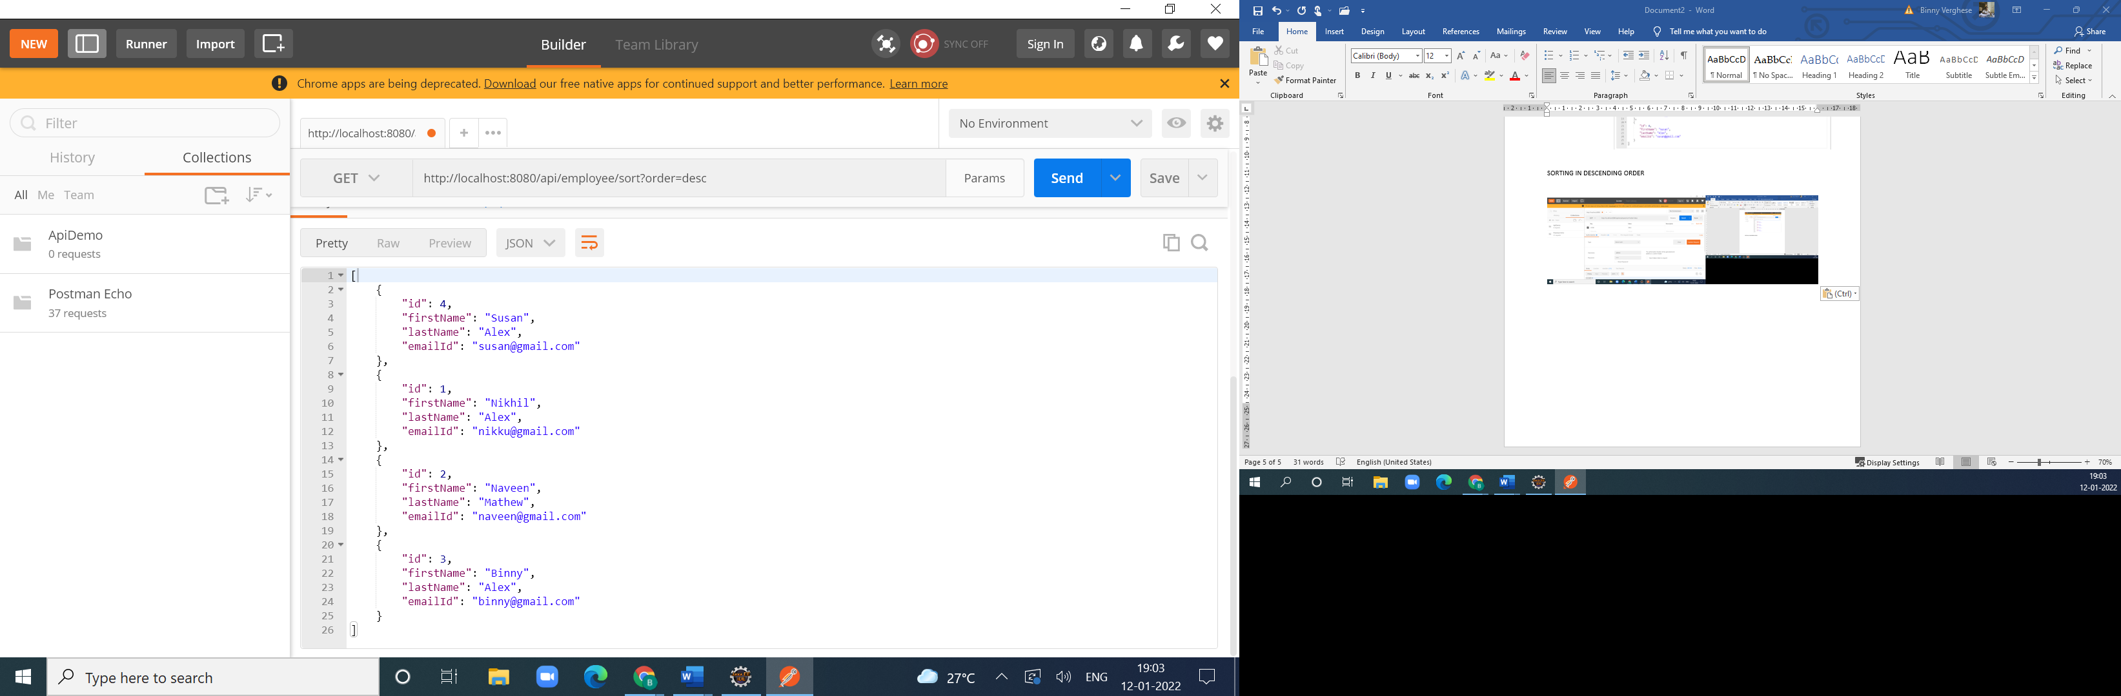

**ADDING A USER USER2**

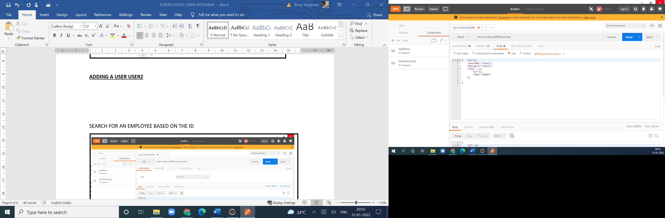

**Response Body**

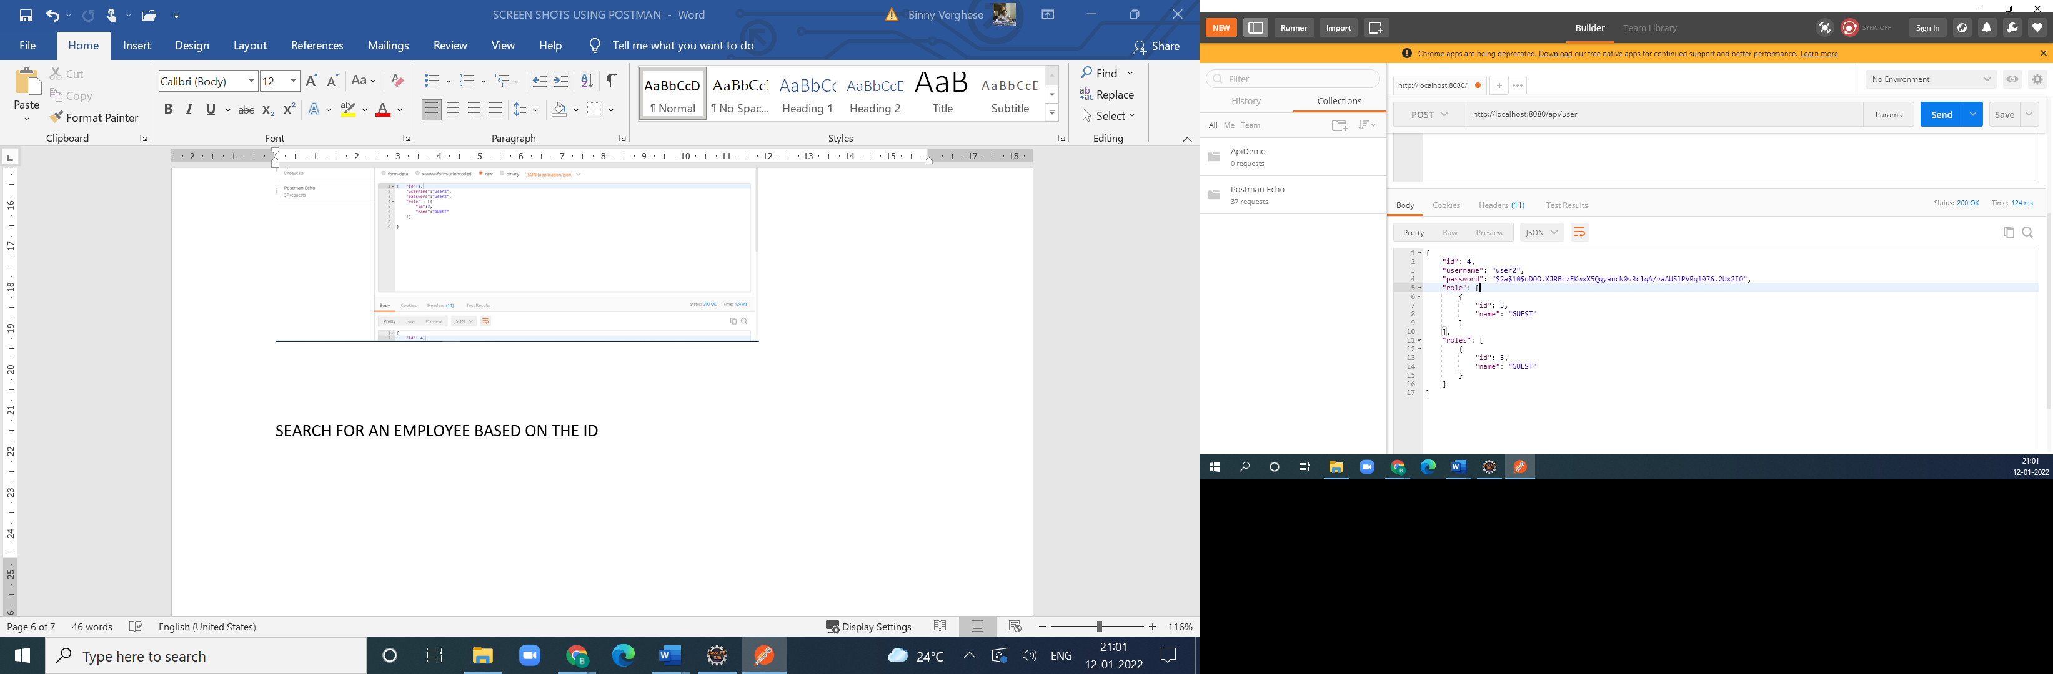

**TABLE AS PER USERS_ROLES IN H2- CONSOLE is**

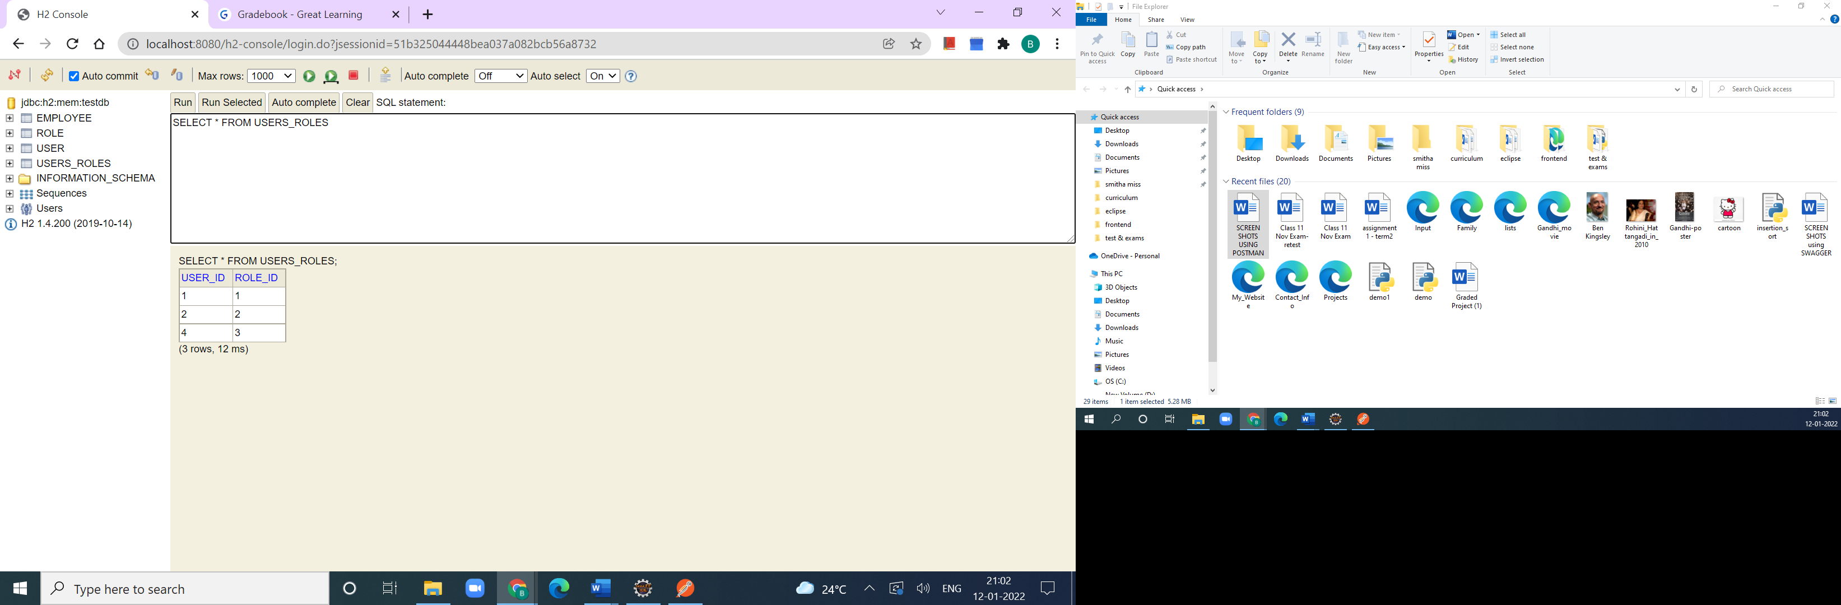

**SEARCH FOR AN EMPLOYEE BASED ON THE ID**

